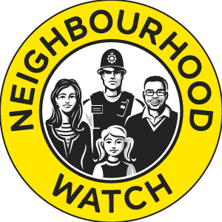

Greenwich Neighbourhood Watch Connect Network

NEW SCHEME SETUP GUIDE

Welcome to the Neighbourhood Watch Family.

Setting up a new scheme can be quite daunting and so we have prepared this short and simple guide to cover the basics.

When setting up a new scheme, you need to define where it is, i.e the road or block in which you live.

So, now you have that sorted, how about recruiting your neighbours to start with you and build a safer community where you live. Not everyone in your street or block needs to join a scheme, in order for it to work. It will work as long as there are enough residents to keep an eye out for each other and to liaise with the police.

Contact your local Safer Neighbourhood Policing Team and let them know that you wish to start a scheme in your area, as the more effective scheme will be, so to find your local policing team, these are ward by ward (voting areas), so the best way of finding them is by visiting www.met.police.uk 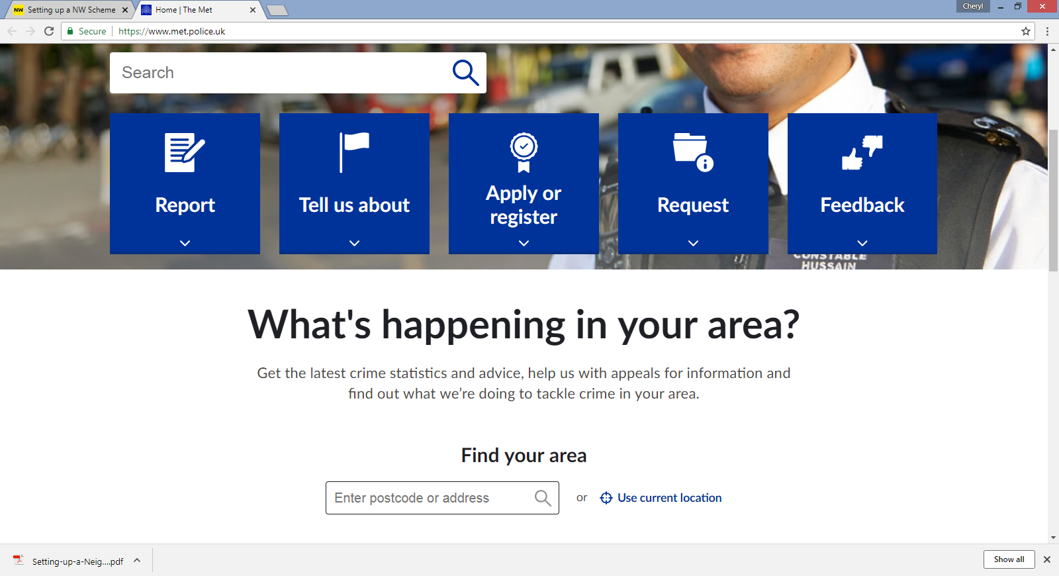
Scroll down to What’s happening in your area? And you will find Find your area. Type in your postcode and details of your local policing team will be on the screen.
If you scroll down the page, it will give you information about the Safer neighbourhood Team in your area and contact details.

The following information has been provided by the National Neighbourhood Watch for information:
The Coordinator
Each scheme has a coordinator who acts as the key contact point for the scheme. They liaise with the police, scheme members and the general public – for instance, people who are interested in joining the scheme – as well as non-member residents when necessary. A scheme may have more than one coordinator as long as members and police know who the key contacts are. The coordinator ensures a smooth flow of information and communication between the police and scheme members.
Size and coverage of your scheme
There are no hard and fast rules about the size of a Neighbourhood Watch scheme. This can vary depending on the geography of the area. A good rule is to think about which houses can see each other, so that they can keep an eye open for any suspicious activity. But some schemes don’t fit into that model, such as long straight roads, blocks of flats and rural areas where houses are widely spaced, so just choose what works best for you!
Here are some things to think about when setting up your scheme:
• Do you need a deputy or second coordinator?
• Do you need to set up a small committee?
• Do you need to appoint a treasurer?
• How will you cover the costs of running the scheme (e.g. newsletters, meetings)?
• How will you raise funds if needed?
• How will you communicate with members?
• How will you communicate with the police?
• Will you produce newsletters? If so, how often and who will produce them?
• How often will you meet and where?
• How will you deal with new requests for membership?
Activities & partnerships
Traditionally, Neighbourhood Watch activities have focused on the immediate vicinity of homes, with members looking out for anything suspicious and helping their neighbours. However, more and more schemes are broadening their work to target a range of other problems such as cyber-crime, anti-social behaviour, vandalism and graffiti. When links are made with other local schemes and wider alliances are formed, the membership can become a powerful voice within a community and get actively involved in problem-solving.
Neighbourhood Watch is well-known to help reduce burglary, anti-social behaviour, doorstep crime and environmental problems. But criminals are no longer constrained by geographical boundaries, and in recent years there has been a steady rise in fraud and cybercrime.
Neighbourhood Watch is in a strong position to help tackle this kind of crime as well, by being a trusted source of information and support for people within their communities and keeping their eyes open for those who might be vulnerable. Victims of fraud and cybercrime might be embarrassed to confide in their families, or worry about losing their independence, and may not know that a crime has been committed or feel that they can’t report it to the police. This is where Neighbourhood Watch members and coordinators can help.
As well as the police, Neighbourhood Watch schemes may also work with other agencies within their area who have an interest in reducing crime and building stronger communities. These may include Community Safety Partnerships (CSPs), local authority environmental and social care teams, Trading Standards services, and Fire & Rescue services. You might also want to link up with other community groups like Residents’ Associations and special interest or cultural groups.

But just for now, let’s just start with a simple scheme.

On the next few pages we will provide you with membership forms, how to register your scheme on the ourwatch.org webpage and also invite you to join our network of coordinators in using our new connect network.

New Scheme Checklist
So you want to start a new scheme, what do you do?

- Look up on www.ourwatch.org for existing schemes or to register to start a new scheme.
- Contact your local Safer Neighbourhood Policing Team, find them by searching www.met.police.uk or call 101
- Talk to your neighbours about joining the scheme with you
- Join our Connect Network and chat with other coordinators and Ward Coordinators
- Set up a meeting with your neighbours to talk about the areas of concern that led you to start the scheme.
- Go to your local Safer Neighbourhood Ward Panel, this is where members of the public and the police discuss concerns and set priorities for local policing. These are generally every 3 months but some areas do them more regularly, so please check our network Ward Specific Pages Area.
- Membership Forms (change Red parts to suit your Neighbourhood Watch Scheme)

WOOLWICH RIVERSIDE WARD NEIGHBOURHOOD WATCH
Please can you complete this form for our information: All details are given in the strictest confidence and will only be used by the Woolwich Riverside Ward Neighbourhood Watch and MET Police Safer Neighbourhood Team for their sole use.
BASIC INFORMATION
Title | Mr/Mrs/Miss/Ms/Rev/Other
First Name
Surname
Date Of Birth
Address
Postcode
Tel (Home)
Tel (Mobile)
Email Address

In the Neighbourhood Watch we have a couple of roles:
- a co-ordinator, who runs the watch for his or her road/s, blocks etc
- a member who doesn’t want to co-ordinate but would like to join and become part of the scheme

Please indicate below what you are interested in doing:
- Coordinator
- Member

If you become a coordinator please agree that you will only use Coordinator and Member details for the purpose of Neighbourhood Watch scheme.

I confirm that I am agreeing to join the Woolwich Riverside Ward Neighbourhood Watch Scheme in the capacity indicated above.

______________________________ _________________
SIGNATURE DATE

